Q. Demonstrate the Static Routing in Packet Tracer.

Aim : To configure and demonstrate static routing between two networks using two routers in Packet Tracer.

Steps :
1.In packet tracer place 2 PCs and 2 Routers.
2.Connect Router0 with PC0 via FastEthernet0/0 using cross-copper cord and Router1 with PC1 via FastEthernet0/0 using cross-copper cord.
3.Connect both routers via FastEthernet0/1 using cross-copper cord.
4.Set the IP address and default gateway of both the PCs in IP configuration of both PCs respectively.

Topology :
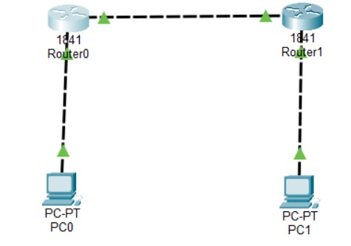

Code
Router0 configuration
Router>enable
Router#configure terminal
Router(config)#interface FastEthernet0/0
Router(config-if)#ip address 10.0.0.1 255.0.0.0
Router(config-if)#no shutdown
Router(config-if)#exit
Router(config)#interface FastEthernet0/1
Router(config-if)#ip address 20.0.0.1 255.0.0.0

Router(config-if)#no shutdown

Router(config-if)#exit
Router(config)#ip route 40.0.0.0 255.0.0.0 20.0.0.2
Router(config)#exit

Router1 configuration
Router>enable
Router#configure terminal
Router(config)#interface FastEthernet0/1
Router(config-if)#ip address 20.0.0.2 255.0.0.0
Router(config-if)#no shutdown
Router(config-if)#exit
Router(config)#interface FastEthernet0/0
Router(config-if)#ip address 40.0.0.1 255.0.0.0
Router(config-if)#no shutdown
Router(config-if)#exit
Router(config)#ip route 10.0.0.0 255.0.0.0 20.0.0.1
Router(config)#exit

PC 0 :
C:\>ipconfig
C:\>ping 10.0.0.1
C:\>ping 20.0.0.1
C:\>ping 20.0.0.2
C:\>ping 40.0.0.1
C:\>ping 40.0.0.2

PC 1:
C:\>ipconfig
C:\>ping 40.0.0.1
C:\>ping 20.0.0.2
C:\>ping 20.0.0.1
C:\>ping 10.0.0.1
C:\>ping 10.0.0.2

OUTPUT
PC 0:
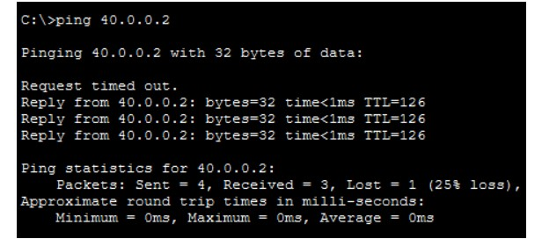

PC 1:
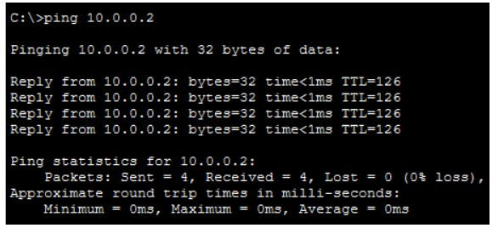

Conclusion :
The above network topology has been executed successfully and static routing has been demonstrated. Communication between PC0 (10.0.0.2) and PC1 (40.0.0.2) across two routers has been verified with successful ping results.

MAJOR PRACTICAL 2

